МІНІСТЕРСТВО ОСВІТИ І НАУКИ УКРАЇНИ

НАЦІОНАЛЬНИЙ ТЕХНІЧНИЙ УНІВЕРСИТЕТ

«Харківський Політехнічний Інститут»

Кафедра стратегічного управління

ЗВІТ

з лабораторної роботи №2

з дисципліни «Основи веб-технологій»

Перевірила

старший викладач Мошко Є. О.

Виконав:

ст. гр. КН-27

Харків – 2019

**Тема:** разработка сайта средствами HTML и CSS

**Задание:**

1. Сверстать шаблон страниц сайта, используя приемы табличной верстки, согласно варианту задания.
2. При создании шаблона строго выдержать принцип разделения структуры (применять HTML) и представления (применять только CSS).
3. Типа макета (каркаса) шаблона должен быть с фиксированной шириной. Ширину макета выбрать на основании табл. 2.1 и рис. 2.4.
4. Проверить шаблон на соответствие стандартам W3C и на совместимость с наиболее популярными в Украине и в мире браузерами.
5. На основании шаблона создать сайт, состоящий минимум из 5 страниц.
6. Тематика сайта – произвольная.
7. Требования к структуре каталога сайта соответствуют требованиям из лабораторной работы No1.
8. На защите л.р. представить сайт и шаблон.

Вариант 2 –

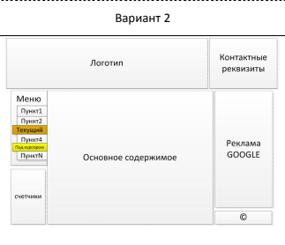

**Ход работы**

1. Общий вид сайта показан на рисунке 1

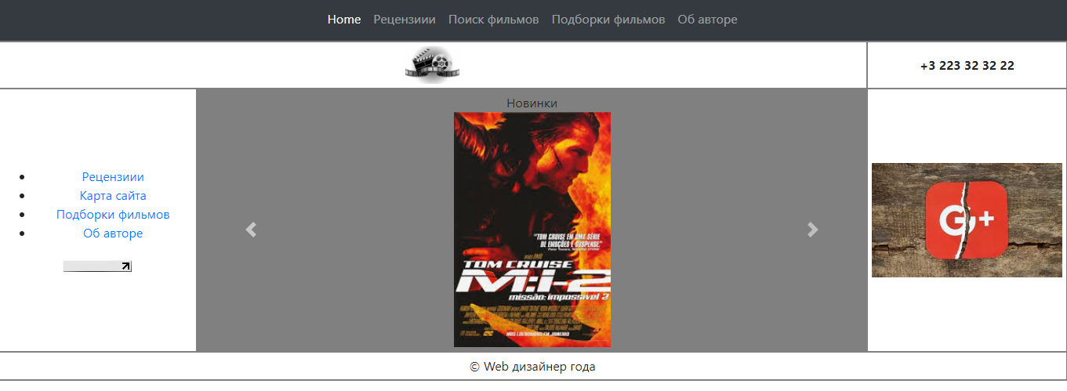

Рисунок 1 – Общий вид

Страница об авторе – рисунок 2

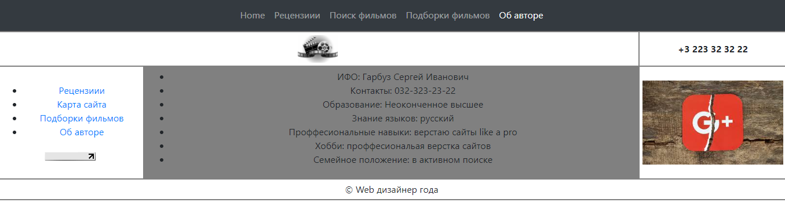

Рисунок 2 – Об авторе

1. Стили css представлены ниже

Файл style.css

|  |
| --- |
| #main td{  border : 2px solid gray;  text-align : center;  padding : 5px;  /* vertical-align: 0px; */  }  #logo img{  height : 100%;  }  .third-clmn img{  width : 100%;  }  #logo{  width : 910px;  height : 60px;  }  .first-clmn{  width : 255px;  }  .third-clmn{  width : 255px;  }  .second-clmn{  width : 855px;  }  .carousel-inner, carousel-item, active{  width: 200px;  margin: auto;  }  #content img{  height: 300px;  }  #content{  background-color: grey;  }  .review{  text-align : left;  } |

1. Пример разметки html представлен ниже (страница Home)

|  |  |  |  |  |  |  |  |  |  |  |  |  |  |  |  |  |  |  |  |  |  |  |  |  |  |  |  |  |  |  |  |  |  |  |  |  |  |  |  |  |  |  |  |  |  |  |  |  |  |  |  |  |  |  |  |  |  |  |  |  |  |  |  |  |  |  |  |  |  |  |  |  |  |  |  |  |  |  |  |  |  |  |  |  |  |  |  |  |  |  |  |  |  |  |  |  |  |  |  |  |  |  |  |  |  |  |  |  |  |  |  |  |  |  |  |  |  |  |  |  |  |  |  |  |  |  |  |  |  |  |  |  |  |  |  |  |  |  |  |  |  |  |  |  |  |  |  |  |  |  |  |  |  |  |  |  |  |  |  |  |  |  |  |  |  |  |  |  |  |  |  |  |  |  |  |  |  |  |  |  |  |  |  |  |
| --- | --- | --- | --- | --- | --- | --- | --- | --- | --- | --- | --- | --- | --- | --- | --- | --- | --- | --- | --- | --- | --- | --- | --- | --- | --- | --- | --- | --- | --- | --- | --- | --- | --- | --- | --- | --- | --- | --- | --- | --- | --- | --- | --- | --- | --- | --- | --- | --- | --- | --- | --- | --- | --- | --- | --- | --- | --- | --- | --- | --- | --- | --- | --- | --- | --- | --- | --- | --- | --- | --- | --- | --- | --- | --- | --- | --- | --- | --- | --- | --- | --- | --- | --- | --- | --- | --- | --- | --- | --- | --- | --- | --- | --- | --- | --- | --- | --- | --- | --- | --- | --- | --- | --- | --- | --- | --- | --- | --- | --- | --- | --- | --- | --- | --- | --- | --- | --- | --- | --- | --- | --- | --- | --- | --- | --- | --- | --- | --- | --- | --- | --- | --- | --- | --- | --- | --- | --- | --- | --- | --- | --- | --- | --- | --- | --- | --- | --- | --- | --- | --- | --- | --- | --- | --- | --- | --- | --- | --- | --- | --- | --- | --- | --- | --- | --- | --- | --- | --- | --- | --- | --- | --- | --- | --- | --- | --- | --- | --- | --- | --- | --- | --- | --- | --- |
| |  |  | | --- | --- | |  | <!doctype html> | |  |  | |  | <html lang="en"> | |  | <head> | |  | <meta charset="utf-8"> | |  |  | |  | <title>The HTML5 Herald</title> | |  | <meta name="description" content="The HTML5 Herald"> | |  | <meta name="author" content="SitePoint"> | |  |  | |  | <link rel="stylesheet" href="<https://stackpath.bootstrapcdn.com/bootstrap/4.3.1/css/bootstrap.min.css>" integrity="sha384-ggOyR0iXCbMQv3Xipma34MD+dH/1fQ784/j6cY/iJTQUOhcWr7x9JvoRxT2MZw1T" crossorigin="anonymous"> | |  | <script src="<https://code.jquery.com/jquery-3.3.1.slim.min.js>" integrity="sha384-q8i/X+965DzO0rT7abK41JStQIAqVgRVzpbzo5smXKp4YfRvH+8abtTE1Pi6jizo" crossorigin="anonymous"></script> | |  | <script src="<https://cdnjs.cloudflare.com/ajax/libs/popper.js/1.14.7/umd/popper.min.js>" integrity="sha384-UO2eT0CpHqdSJQ6hJty5KVphtPhzWj9WO1clHTMGa3JDZwrnQq4sF86dIHNDz0W1" crossorigin="anonymous"></script> | |  | <script src="<https://stackpath.bootstrapcdn.com/bootstrap/4.3.1/js/bootstrap.min.js>" integrity="sha384-JjSmVgyd0p3pXB1rRibZUAYoIIy6OrQ6VrjIEaFf/nJGzIxFDsf4x0xIM+B07jRM" crossorigin="anonymous"></script> | |  |  | |  |  | |  | <link rel = "stylesheet" href = "[style.css](http://localhost:8080/style.css)"> </head> | |  |  | |  | <body> | |  | <script src="[js/scripts.js](http://localhost:8080/js/scripts.js)"></script> | |  | <nav class="navbar navbar-expand-lg navbar-dark bg-dark"> | |  | <button class="navbar-toggler" type="button" data-toggle="collapse" data-target="#navbarsExample08" aria-controls="navbarsExample08" aria-expanded="false" aria-label="Toggle navigation"> | |  | <span class="navbar-toggler-icon"></span> | |  | </button> | |  | <div class="collapse navbar-collapse justify-content-md-center" id="navbarsExample08"> | |  | <ul class="navbar-nav"> | |  | <li class="active nav-item"> | |  | <a class="nav-link" href="[/](http://localhost:8080/)">Home<span class="sr-only">(current)</span></a> | |  | </li> | |  | <li class="nav-item"> | |  | <a class="nav-link" href="[reviews](http://localhost:8080/reviews)"><span class="glyphicon glyphicon-search" aria-hidden="true"></span>Рецензиии</a> | |  | </li> | |  | <li class="nav-item"> | |  | <a class="nav-link" href="[sitemap](http://localhost:8080/sitemap)">Поиск фильмов</a> | |  | </li> | |  | <li class="nav-item"> | |  | <a class="nav-link" href="[albums](http://localhost:8080/albums)">Подборки фильмов</a> | |  | </li> | |  | <li class="nav-item"> | |  | <a class="nav-link" href="[about](http://localhost:8080/about)">Об авторе</a> | |  | </li> | |  | </ul> | |  | </div> | |  | </nav> | |  | <table id = "main"> | |  | <tr> | |  | <td id = "logo" colspan="2"><a href = "[/](http://localhost:8080/)"><img src = "[img/logo.png](http://localhost:8080/img/logo.png)" alt = "home"></a></td> | |  | <td id = "contacts" class = "third-clmn"><strong>+3 223 32 32 22</strong></td> | |  | </tr> | |  | <tr> | |  | <td id = "menu" class = "first-clmn"><ul> | |  | <li><a href="[reviews](http://localhost:8080/reviews)"><span class="glyphicon glyphicon-search" aria-hidden="true"></span>Рецензиии</a></li> | |  | <li><a href="[sitemap](http://localhost:8080/sitemap)">Карта сайта</a></li> | |  | <li><a href="[albums](http://localhost:8080/albums)">Подборки фильмов</a></li> | |  | <li><a href="[about](http://localhost:8080/about)">Об авторе</a></li> | |  | </ul> | |  |  | |  | <img src="[//counter.yadro.ru/logo?23.2](http://counter.yadro.ru/logo?23.2)" title="LiveInternet: показано число посетителей за сегодня" alt="" width="88" height="15"></td> | |  | <td id = "content" class = "second-clmn"> | |  |  | |  | Новинки | |  | <div style = "height : 100%" id="carouselExampleControls" class="carousel slide" data-ride="carousel"> | |  | <div class="carousel-inner"> | |  | <div class="carousel-item active"> | |  | <img src="[img/img1.jpg](http://localhost:8080/img/img1.jpg)" class="d-block w-100" alt="..."> | |  | </div> | |  | <div class="carousel-item"> | |  | <img src="[img/img2.jpg](http://localhost:8080/img/img2.jpg)" class="d-block w-100" alt="..."> | |  | </div> | |  | <div class="carousel-item"> | |  | <img src="[img/img3.jpg](http://localhost:8080/img/img3.jpg)" class="d-block w-100" alt="..."> | |  | </div> | |  | </div> | |  | <a class="carousel-control-prev" href="[#carouselExampleControls](http://localhost:8080/#carouselExampleControls)" role="button" data-slide="prev"> | |  | <span class="carousel-control-prev-icon" aria-hidden="true"></span> | |  | <span class="sr-only">Previous</span> | |  | </a> | |  | <a class="carousel-control-next" href="[#carouselExampleControls](http://localhost:8080/#carouselExampleControls)" role="button" data-slide="next"> | |  | <span class="carousel-control-next-icon" aria-hidden="true"></span> | |  | <span class="sr-only">Next</span> | |  | </a> | |  | </div> | |  |  | |  | </td> | |  | <td id = "ads" class = "third-clmn"><a href = "[https://google.com](https://google.com/)"><img src="[img/google_plus.jpg](http://localhost:8080/img/google_plus.jpg)" alt = "..."></a></td> | |  | </tr> | |  | <tr> | |  | <td colspan="3">© Web дизайнер года</td> | |  | </tr> | |  | </table> | |  | </body> | |  | </html> | |

1. Сайт был проверена верификатором w3с – рисунок 3-4

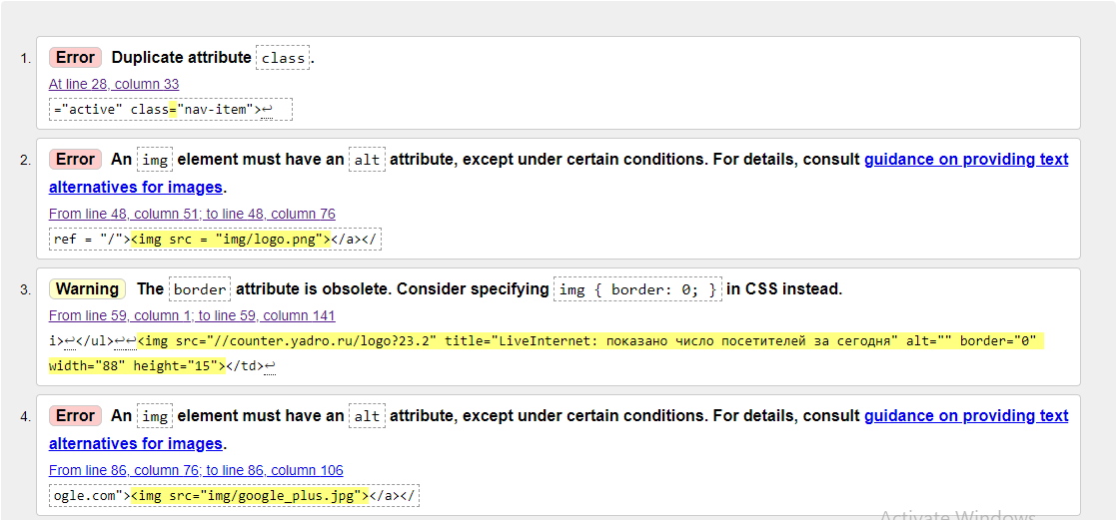

Рисунок 3 – Ошибки, найденные верификатором



Рисунок 4 – После ликвидации ошибок

**Выводы**

При выполнении лабораторной работы была выбрана тема, создано несколько страниц с картинками, ссылками и меню. Были подключены стили CSS.